**CMSC 203 Assignment 6 Report**

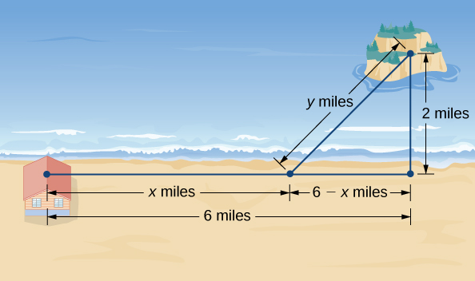**Description**

An island is 2mi due north of its closest point along a straight shoreline. A visitor is staying at a cabin on the shore that is 6mi west of that point. The visitor is planning to go from the cabin to the island. Suppose the visitor runs at a rate of 8mph and swims at a rate of 3mph. How far should the visitor run before swimming to minimize the time it takes to reach the island?

**Operation**

* We need to find the distance the visitor should run along the shore before swimming to get to the island in minimum time possible.
* A brief summary of the program is displayed when “Optimize the function” is selected.
* The program will then ask for left extent(cannot be < 0 as time cannot be negative) and right extent.
* Graph of the optimized function and the option to repeat will be displayed at the end.

**Specifications:**

When we run the GUI, a pop-up is displayed with exit and “Optimize the function” button. When optimize is pressed, a JavaFX alert is opened tells the user the description of the problem. The left and right extents are asked, (Domain of the graph). GUI creates a graph of the optimized function showing only the domain that the user input.

**Findings**

Using this program, we find the optimal running and swimming distance to get to an island in minimum time. We consider Tr and Ts, as running time and swimming time respectively. Take x as the running distance and y as swimming distance. Time is calculated as Distance over rate. So, Tr = x / 8 and Ts = y / 3, making T = x /8 + y / 3. Total amount of time, T= Tr + Ts. According to Pythagorean theorem, y = sqrt( ( 6 – x ) ^ 2 + 4). So, T = x / 8 + (sqrt( ( 6 – x ) ^ 2 + 4) / 3. We use this for fnValue. For getY, we use sqrt( ( 6 – x ) ^ 2 + 4. After running the program, we find that the visitor must run 5.19 miles along shore then swim 2.16 miles to reach the island in the minimum time of 1.37 hours.